ID: 123(type your abstract ID)

The Full Paper Guidelines and Instructions (Cryogenics 2012)
Replace this Model Paper with your Text

Smith A.*, Jones B.**, Nowak C.**
* Organization, Postal address, City, Zip code, Country
** ICARIS spol. s r.o., Malé náměstí 144/1, Praha 1, 110 00, Czech Republic

ABSTRACT
Authors are requested to prepare their papers exactly in accordance with the instructions given below. The abstract should contain at most 150 words in English. The entire manuscript (abstract, text, figures, tables and references) should not exceed 6 pages.
The manuscript should be submitted via the e-mail address Romana@icaris.cz in Microsoft Word format (.doc) and Adobe Acrobat Reader format (.pdf). Name the manuscript in the following format: paper ID, presenting author’s last name (example: 021_smith.doc and 021_smith.pdf).
Use defined styles.
- INTRODUCTION
The manuscripts should report on original research or on technical developments and their applications. They should contain quality scientific or technical information. Manuscripts of a commercial nature will be rejected and will not be authorized for presentation. The process of validation and acceptance and/or rejection of papers shall be under the authority of a Programme Committee, which will not be held responsible for any errors appearing in the final text. Authors assume sole responsibility for their manuscript, both for its form and its substance, and are invited to check their manuscripts thoroughly before submittal.
- AUTHORS
The number of authors should be limited to four (4), except in exceptional circumstances. The last (family) name should be given first, followed by the initials of the author. The presenting author should be the first.
Separate names by commas.

Affiliations should be written using the following structure: Department, Institution, City, Country.
Separate affiliations by semicolons. Do not write e-mail contacts or phone/fax numbers in your affiliations.

Use English alphabet only, no specific national characters (umlauts, wedges, accents, etc.).
Asterisks, no numbers should be used to indicate which address goes with which author. Use no asterisks if all authors are from one institute/company.
- FORMAT AND MARGINS
  - Paper size:
Set the paper size A4 (width 210 mm, height 297 mm). All text of the manuscript must be located within a 170 mm by 252 mm rectangle of an A4 page. The margins are given in Table 1. An example of the page format is given in Figure 1. Do not use page numbering.
  - Manuscript title:
Times New Roman, 14 points, centred, boldface type, written in capital letters. Add the blank space 18-points after the title, do not leave blank lines (Use: Format → Article/Paragraph → Indentations → Spaces).
  - Text:
Times New Roman, 11-points, single spaced, justified block.
Do not use page numbering.
Do not use footnotes.
Turn off the “track changes” function.
  - Header and footer:
Authors are asked to add a one-line left-justified header and footer on each page of the manuscript. The header and the footer shall be placed 12.7 mm from the bottom edge of the page. Leave the header and the footer – the editors will insert the paper ID and sequential pagination there.
Table 1. Page margins of manuscripts. Enter one blank line below each Table.
Margin  Position | Top | Bottom | Left | Right
Margin size  (mm) | 20 | 25 | 20 | 20

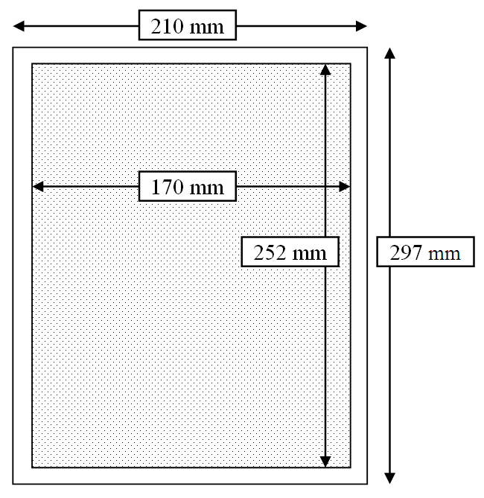
Figure 1. Text area of manuscripts. Enter one blank line above each Figure.
- HEADINGS
Titles of all sections should be 12-points, centred, and in boldface capital letters. Blank space 12-points (not a blank line) should be placed above and below the titles.
  - Sub-Section Headings
Sub-section headings should be in lower-case, 11-points, bold letters and justified left. Blank space 12-points (not a blank line) should be placed above, but not below.
    - Sub-sub-section headings
Sub-sub-sections should be avoided. If used, sub-section headings should be in lower-case, 11-points, regular letters and justified left. Blank space 12-points (not a blank line) should be placed above, but not below.
- TABLES AND FIGURES
Each table should be numbered (Tables 1, 2, 3, etc.), with the caption being placed above the table. Each figure should be numbered (Figures 1, 2, 3, etc.), with the caption being placed below the figure. All tables and figures should be numbered sequentially. Figures and tables should be incorporated in the text and should not run into the margins. Fonts used in figures should be large enough to be legible. Use only a reduces size of your photos and other pictures to keep an allowed size of a final file.
- EQUATIONS
Equations should be aligned left, numbered in order (i.e. (1), (2), (3), etc.) down the right-hand side of the page and cited in the text with its number, e.g. eq. (1). Equations should be separated from the text above and below by a blank space 12-points. If necessary, a symbol-nomenclature glossary should be placed at the end of the manuscript.
c = a + b (1)
where
a = apples [unit], b = bananas [unit], c = fruit salad [kg]
- UNITS
The SI system of units should be used.
- FILE SIZE
Occasionally, Microsoft Word may generate larger-than-necessary .pdf files when images inserted into the document are manipulated in Microsoft Word. To minimize this issue, use an image editing tool to resize the images to the appropriate printing resolution (usually 300 dpi), and then insert the image into Microsoft Word using Insert | Picture | From File...
Reduce the size / pixel resolution of images in the manuscript so that the file size does not exceed 1 MB.
- DISCUSSION
It is important that you write for a general audience. It is also important that your work is presented in a professional fashion. This guideline is intended to help you achieve that goal.

Remember the following:
- Do not wait until the last minute to submit your paper.
- Do not expect to get an extension for submitting your paper.
- If you do not submit your paper according to the guidelines specified in these instructions, there is no guarantee that your paper will be included in the congress proceedings.
- CONCLUSIONS
The paper must describe original authors work, theoretical, experimental or industrial nature. Branch state of art papers would be well invited from recognized scientists. All submitted papers would be reviewed by the Programme Committee for quality, originality and relevance.
Purely commercial papers will be rejected.
At least one author of each paper must be registered and be able to present it at the conference. Authors are expected to cover their own expenses and pay the conference registration fee.
The Proceedings will contain only papers of authors who will pay the conference fee.

Deadline for the full texts is May 15th, 2012.
- REFERENCES
Green L, Lundholl P. 1997, CFC and HCFC refrigerants retrofits, Int. J. Refrig. 20(1): 49-54.
Forbes Pearson S. 1996, Uses of Hydrocarbon Refrigerants, Proc. Aarhus Conference, IIF/IIR: 439-446.
Janna SW. 1986, Engineering Heat Transfer, PWS Publishers, Boston, 769 p.
Duminil M. 1995, Principes de la production du froid, In: Côme D, Ulrich. R. La chaîne du froid – Le froid au service de l'homme, Hermann, Paris: 33-144.

